**Data Structure Practical 2**

**Aim: Implementation of searching algorithms**.

1. **Linear Search**

**Algorithm**:

Linear Search ( Array A, Value x)

Step 1: Set i to 1

Step 2: if i > n then go to step 7

Step 3: if A[i] = x then go to step 6

Step 4: Set i to i + 1

Step 5: Go to Step 2

Step 6: Print Element x Found at index i and go to step 8

Step 7: Print element not found

Step 8: Exit

**Code**:

#include<iostream>

using namespace std;

void showArray(int *entries,int size);

void linearSearch(int *ptr, int size);

int main() {

int n,i;

cout<<"Enter number of elements ";

cin>>n;

int arr[n];

int *ptr=arr;

for(int i=0;i<n;i++) {

cout<<"Enter "<<i+1<<"th Element :";

cin>>ptr[i];

}

ptr=arr;

cout<<"Recorded Details \n";

showArray(ptr,n);

linearSearch(ptr,n);

return 0;

}

void linearSearch(int *ptr, int size){

int find;

int flag=0;

cout<<"Enter the element to search? ";

cin>>find;

for(int i=0;i<size;i++){

if(ptr[i]==find){

cout<<"element found at index = "<<i+1;

flag=1;

break;

}

}

if(flag==0){

cout<<"Element not present in given array.";

}

}

void showArray(int *entries,int size) {

for(int i=0;i<size;i++){

cout<<entries[i]<<"\n";

}

}

**Output**:

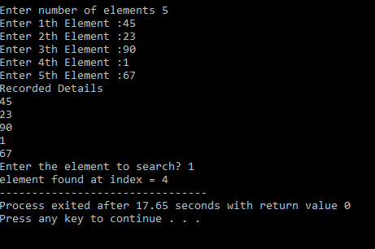

1. **Binary Search**

**Algorithm:**

1. Input an array A of n elements and “data” to be sorted

2. LB = 0, UB = n; mid = int ((LB+UB)/2)

3. Repeat step 4 and 5 while (LB &lt;= UB) and (A[mid] ! =data)

4. If (data & lt; A[mid])

UB = mid–1

5. Else

LB = mid + 1

6. Mid = int ((LB + UB)/2)

If (A[mid]== data)

Display “the data found”

8. Else

Display “the data is not found”

9. Exit

**Code**:

#include<iostream>

using namespace std;

int binarySearch(int list[],int key,int arraySize) {

int start = 0;

int end = arraySize - 1;

int pos;

int mid = int((start+end)/2);

while(start <= end && list[mid]!=key) {

if(key < list[mid])

end = mid -1;

else

start = mid+1;

mid = int((start+end)/2);

}

if(list[mid]==key){

pos = mid;

}

else {

pos = -1;

}

return pos;

}

int main() {

int arraySize,key,list[10],pos;

cout<<"enter number of elements \n";

cin>>arraySize;

cout<<"enter "<<arraySize<<" no of elements in ascending order\n";

for(int i=0;i<arraySize;i++){

cin>>list[i];

}

cout<<"enter the element to search\n";

cin>>key;

pos = binarySearch(list,key,arraySize);

if(pos==-1){

cout<<"element not found\n";

}

else{

cout<<"element found at the position "<<pos+1;

}

return 0;

}

**Output**:

